
SWE4303 – Computing Infrastructure
Assignment 1 - Infrastructural Strategy and Networking Principles
Student ID: HE30838
Module Code: SWE 4303
Module Title: Computing Infrastructure
Module Tutor/s: 4N1 - Reza Akhavan
Cohort: September 2025
Date of Submission: 28th of March 2026

Table of content
Task 1 - Infrastructural Strategy 3
Analysis of Company Requirements 3
Recommended Hardware Infrastructure 4
Logical Network Design 5
Scalability and Reliability 6
Traditional and Contemporary Infrastructure Components 7
Network Topology Selection 8
TASK 2 - Network Implementation and Configuration 9
IP Addressing 9
Routing and Connectivity 11
Network Services and Protocols 12
Connectivity Testing 15
Security Considerations 16
Personal Reflection 19
References (Harvard) 20

Task 1 - Infrastructural Strategy

Analysis of Company Requirements
In the scenario, the company is made up of about 50 people and the building is only a one-floor office. Half of the employees work from home or other offices, so the business depends on a strong communication network to allow them to talk, work and have access to elements like emails and websites. Also, the company is starting to think about using cloud services that will help them to increase and get more flexible.
To fulfill the request, the system must support two physical offices and employees working remotely through the internet. On-site, the offices have to make a working reliable LAN environment for workers, in the same way, remote working would be a way for the workers to have a secure connection access to company resources via the internet. If the company grows later, the system should be designed so it can easily be expanded as the organisation increases in size.
That is why the suggested one has two parts on premise which are the computer centre and the computer laboratory or study + cloud-based services. This hybrid infrastructure mix staff's control over internal resources while the organisation benefits from the flexibility and scalability of cloud computing.

Recommended Hardware Infrastructure
You need a reliable hardware setup that will allow for a smooth connection and effective network performance at both offices. Each office should have a main router that handles communication with the internet and links the internal network with other locations.
Routers direct traffic between different networks and facilitate communication between the two offices and remote employees. Enterprise grade routers like Cisco Integrated Services Routers (ISR) are ideal for this setup because they not only support routing protocols but also VPN connectivity and network security features.
Switching devices are quite necessary when it comes to connecting different devices within a single office LAN. Managed switches provide quite a lot of power to network administrators such as monitoring network traffic, segmenting networks, and supporting VLANs. In this case, Layer 2 switches should suffice since routing is handled by the routers.
Servers will be necessary for the implementation of local services such as file sharing, login verification, and hosting of applications. Based on the services desired, the servers can be running either Windows Server OS or Linux. Besides that, network access for employees will be through office LAN desktop/laptop computers.
For remote employees, personal standard computers with secure internet connections will be the medium used. They will be able to connect to the company's network through secure remote access mechanisms such as Virtual Private Networks (VPN).
The infrastructure consists of several dedicated servers: a DNS server, a DHCP server, an Email server, a Web server and an FTP server. These servers are housed in a separate server network (VLAN 50) to enhance the reliability, security and management of network services.

Logical Network Design
The logical network design includes two office LAN environments connected via routers and the public internet. Each office is equipped with a switch linking the local devices such as employee computers and internal servers.
The two LANs are connected by routed communication allowing data to move between them. Remote workers use a VPN gateway that is configured on the main router. This method of connection ensures that remote employees have secure access to the company's resources and that data privacy and protection are maintained.
Each gadget on the network is assigned an IP address according to a well-organized addressing plan. Private IP addressing can be used for internal communication only, whereas routers provide the Network Address Translation (NAT) for interaction with the external internet services.
Besides that, this layout makes use of simple cloud infrastructure. For example, a cloud-based server might be used for storing backups, web hosting, or even providing collaborative tools. Cloud infrastructure is also more dependable as users can still access the services when the local systems are down.
The network is divided logically into different departments using VLAN technology. Each department works within its own network segment which helps to increase performance, makes management easier and boosts security within the organisation.
To enhance network performance, security, and traffic flow, the network has been segmented into several VLANs such as VLAN 10, VLAN 20, VLAN 30, VLAN 40, and VLAN 50 for servers. Remote workers first connect to a wireless router and through a VPN connection they gain a secure access to internal company resources.

Scalability and Reliability
When planning the infrastructure, scalability is an essential factor to take into account since it is possible that the company will increase its workforce in the future. The design that has been proposed enables connecting more devices without any hassle to the existing switches in each office. If the user count rises drastically, it is also possible that new switches will have to be installed.
One way of enhancing reliability is by having redundant internet connections or network devices as a backup. A case in point is that routers can be set up with secondary internet connections that will be activated automatically in case the primary connection fails. Besides, the use of cloud-based services can also increase reliability as data can be stored remotely and you can access it even in a case where the local hardware fails.
In the network, static routing is employed for connections between the head office and the remote office to guarantee dependable communication among the facilities. This uncomplicated routing method not only lowers the complexity of the setup but also contributes to the continued stability of the network.

Traditional and Contemporary Infrastructure Components
Traditional infrastructure models are based on the use of physical hardware that is set up in company offices. Such systems offer a high level of control but usually involve substantial expenses for hardware maintenance and upgrading.
Modern infrastructure models are progressively incorporating cloud computing components. Cloud platforms give enterprises the ability to launch their services without being forced to acquire any kind of physical hardware. Infrastructure as a Service (IaaS), for instance, provides firms with the opportunity to host their servers and storage in cloud data centers yet keep the configuration control of the system.
Hybrid infrastructure model is a mix of both strategies. For instance, local servers function for internal services and authentication, whereas cloud platforms offer scalable services such as backup storage, e-mail systems, and web hosting. Besides, this model offers the flexibility of securing and maintaining performance.

Network Topology Selection
Each office network physical topology chosen was a star topology. A star topology is a network configuration where all the devices are connected to a central switch that controls the communication among the nodes. This topology is very popular among office environments as it makes network management and troubleshooting easier.
In case a device fails, the network will still be functional thereby increasing the reliability of the network. What's more, star topology makes it simple to expand as major devices are connected only to central switch which acts as the control point.
A routed network structure is used for communication between the two offices as well as remote workers rather than a simple physical topology. Routers control communication and enable remote access via VPN.
This combination of star topology within offices and routed inter network communication between locations provides an efficient and scalable network design that supports the organisation's operational requirements.

TASK 2 - Network Implementation and Configuration

IP Addressing
The network has adopted the use of private IP addresses in an organized manner to enable communication among various departments and services. Also, a distinct VLAN with a matching IP subnet is assigned to each department for better network management and efficiency. Unique addressing allows devices to communicate reliably across networks and ensures accurate delivery of data between systems (Burns, 2019).
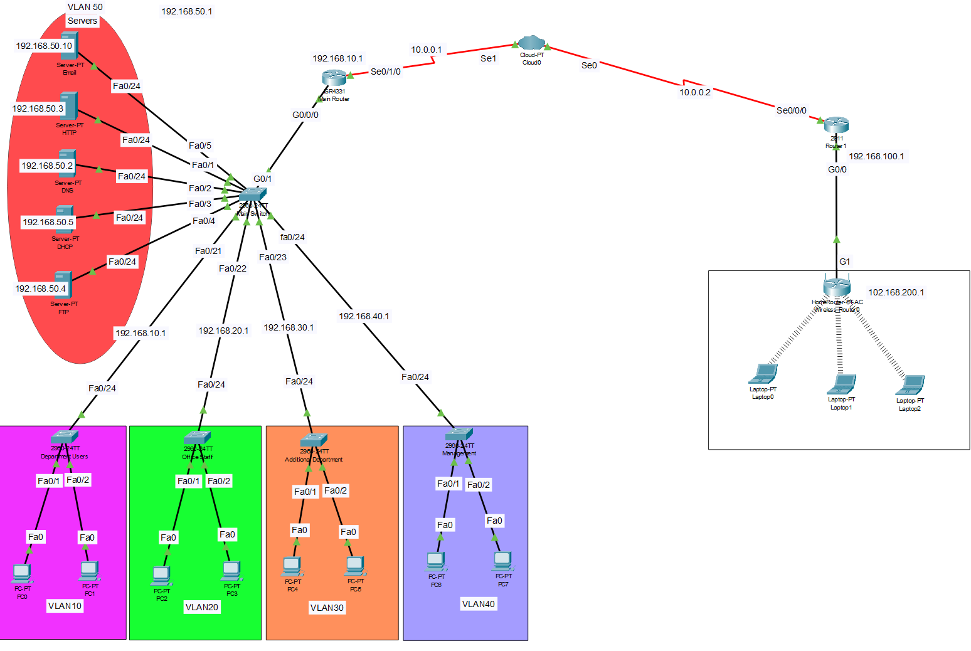
Figure 1 shows complete network topology with routers and servers.
VLAN 10 uses the network 192.168.10.0/24 use among the administrative staff devices.
VLAN 20 uses the network 192.168.20.0/24 for office users.
VLAN 30 uses the network 192.168.30.0/24 for additional department devices.
VLAN 40 uses the network 192.168.40.0/24 for management or specialised users.
VLAN 50 uses the network 192.168.50.0/24 for servers including DNS, DHCP, Email, Web and FTP services.
Every VLAN is assigned a default gateway on the central router using subinterfaces. That way, devices belonging to different VLANs can get in touch with one another through inter-VLAN routing.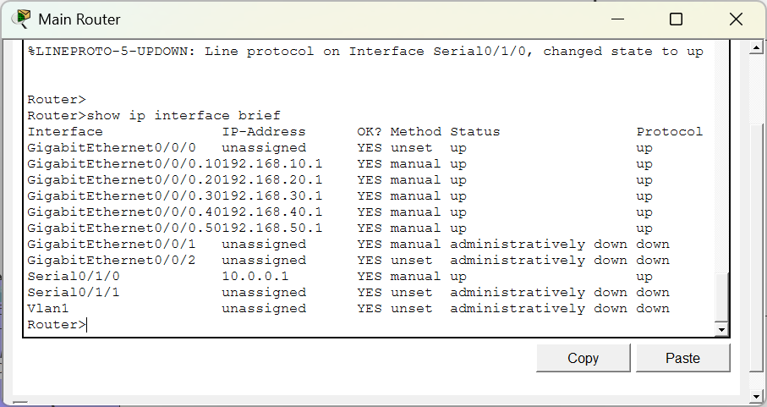
Figure 2 shows VLAN interfaces and IP addressing configuration.
Default Gateway for each VLAN is configured on the main router using subinterfaces.

Routing and Connectivity
The main router is the one that performs routing by inter-VLAN routing. The router uses subinterfaces configured with IEEE 802.1Q encapsulation to route traffic between VLAN networks.
A wide area network (WAN) connection is established between the main office and the remote office using routers connected through a cloud network. Static routing is configured to allow communication between the two locations.
This routing configuration makes sure that all departments and remote users have access to internal network services such as file sharing, email and web applications.
Inter-VLAN routing is set up on the main router by a router-on-a-stick configuration with IEEE 802.1Q encapsulation
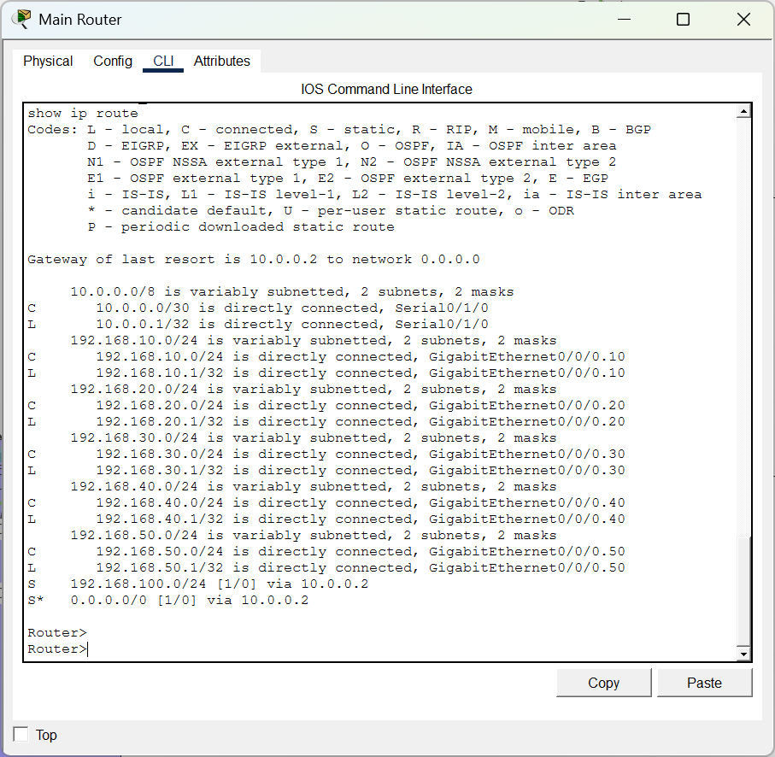
Figure 3 shows routing table with static routes configured.

Network Services and Protocols
The network is equipped with many vital services that enable the business to run smoothly. These services are installed on separate servers that are in VLAN 50.
DHCP server is responsible for changing IP addresses for various devices in the network which lowers manual configuring and enhances network management.
DNS server will convert domain names into IP addresses so that users can access services by names rather than numerical addresses.
In sending and receiving email messages the Email server relies on SMTP and POP3 protocols.
Network monitoring protocols such as SNMP can be used to monitor network devices and ensure system availability (Uytterhoeven, 2019).
The Web server uses the Hypertext Transfer Protocol (HTTP) to deliver web-based content.
The FTP server relies on the File Transfer Protocol (FTP) to give users the ability to securely upload and download files within the network.
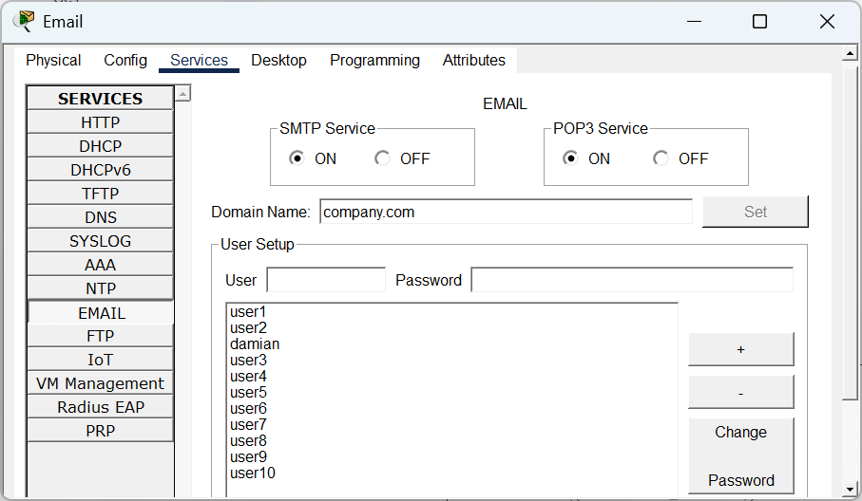
Figure 4 shows email server user accounts configuration.
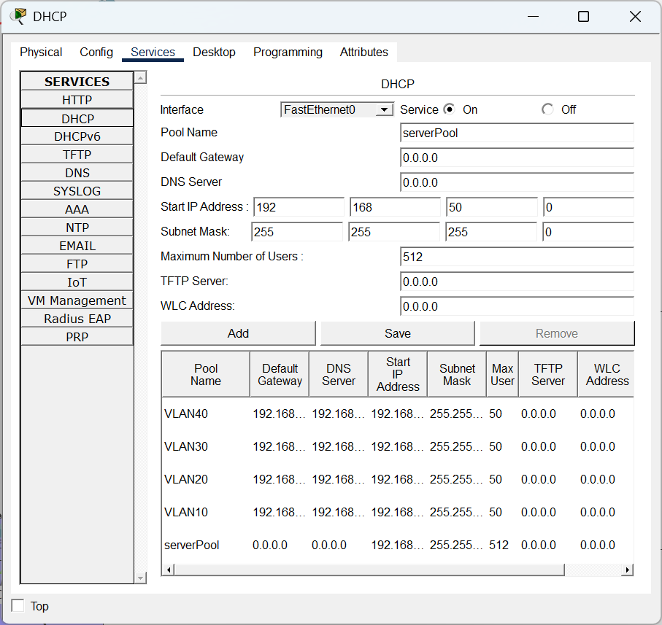
Figure 5 shows DHCP server assigning IP addresses. 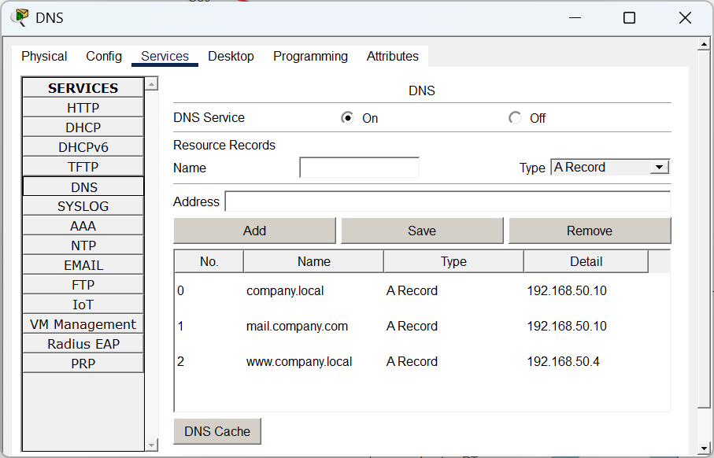
Figure 6 shows DNS server resolving domain names.
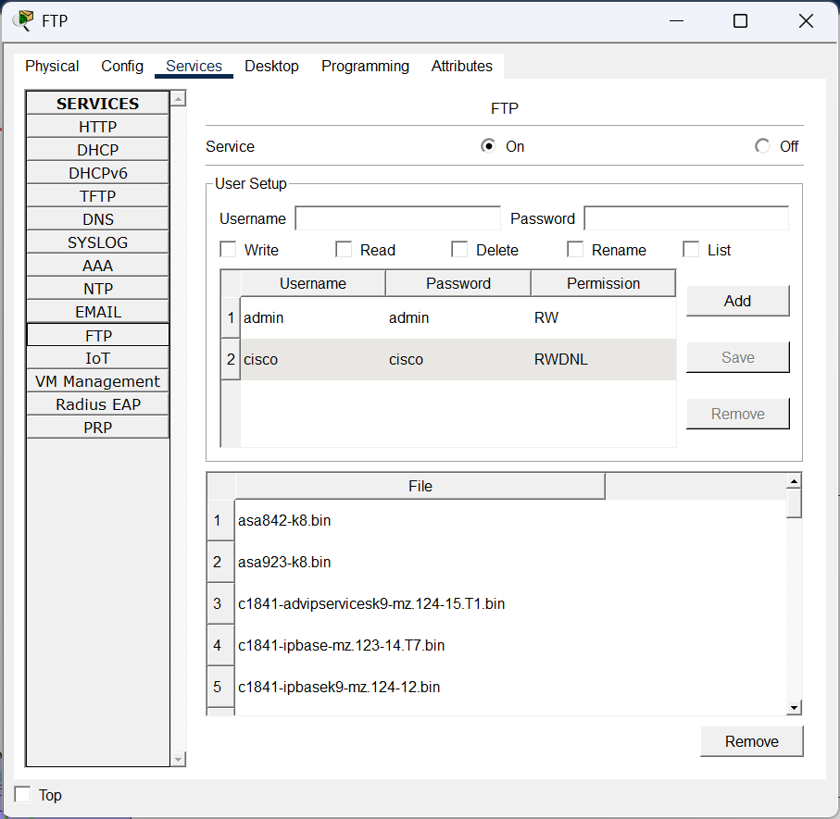
Figure 7 shows FTP server allowing file transfers.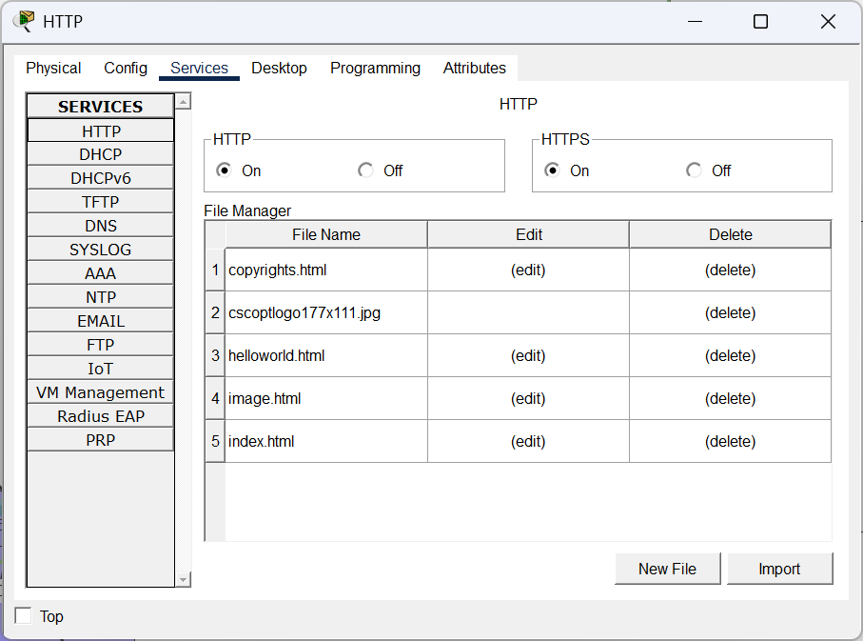
Figure 8 shows web server providing HTTP services.

Connectivity Testing
We used the ping command in Cisco Packet Tracer to check network connectivity. Devices from different VLANs not only communicated successfully with each other but also with the network servers.
An instance can be a PC belonging to VLAN 10 that managed to ping the email server in VLAN 50. This was a clear indication that the setup of inter-VLAN routing and network services was right.
Besides that, we checked whether the main office and remote office could communicate properly via the WAN connection so as to ensure a reliable connection.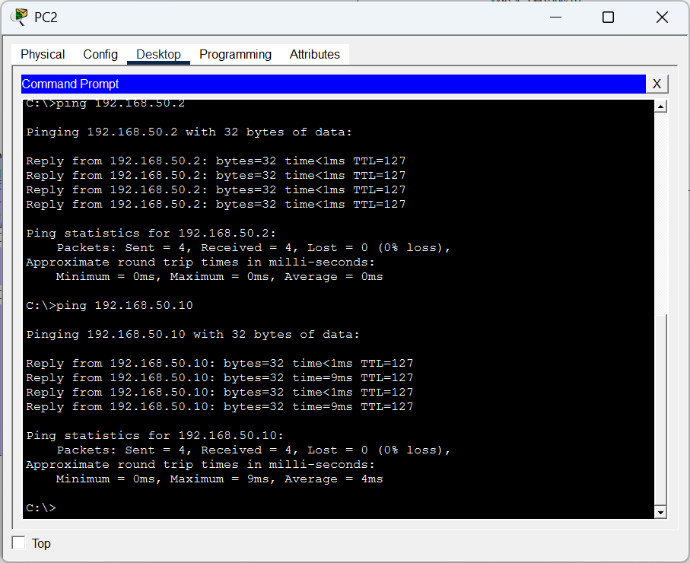
Figure 9 shows successful ping between VLAN networks.

Security Considerations
Several security measures were put in place to safeguard the network and its resources.
VLAN segmentation is one of the ways to separate different departments and at the same time limit unauthorized access to one segment of the network from another.
Password authentication is a must for gaining access to network devices and services like email and file transfer systems.
The router implements Network Address Translation (NAT) ensuring internal IP addresses remain protected while interacting with external networks.
Remote employees get secure remote access by using a Virtual Private Network (VPN) connection.
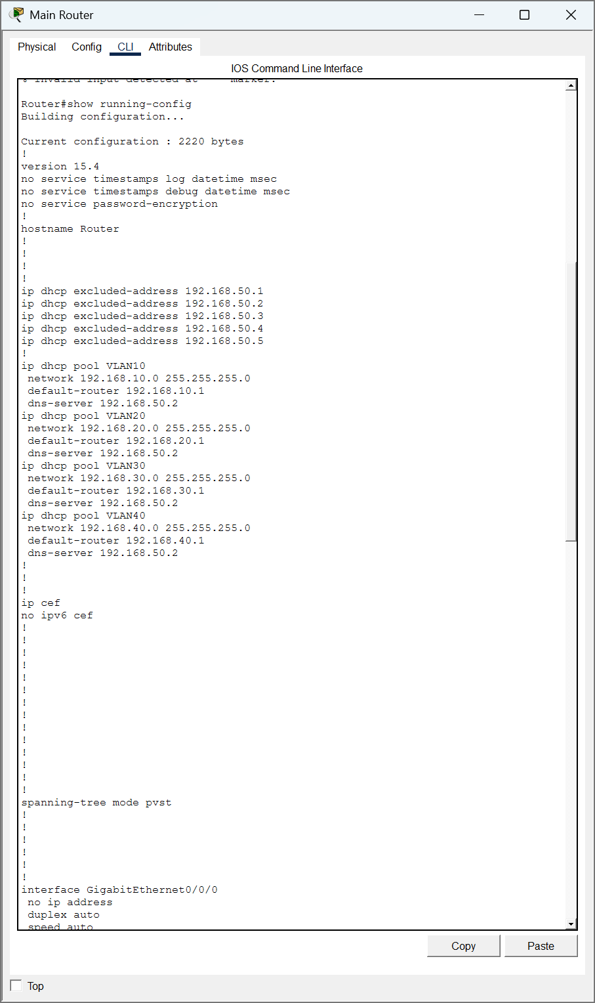
Figure 10 shows NAT translating private IP addresses.
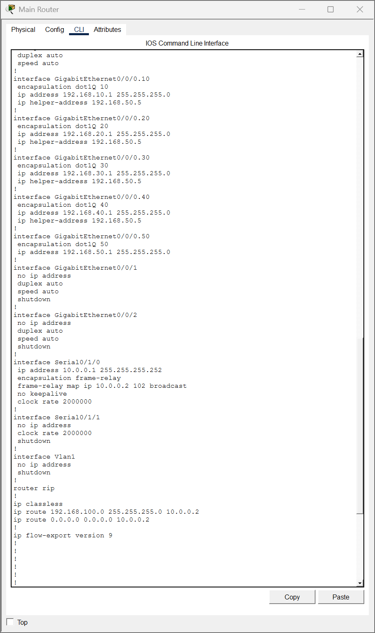
Figure 11 shows VPN providing secure remote access.

Personal Reflection
I used Cisco Packet Tracer software in this project to enhance my knowledge of the computer network design and configuration. Creating VLAN segmentation and allocating IP addresses are the basic things I learned. In addition, configuring routing and executing the network services of DHCP, DNS, Email, FTP, and Web servers, were part of the skills I acquired. The main idea behind this project is the implementation of real-world networks, which helped me be in line with how different components of networking are interacting to give a reliable communication.
One of the biggest issues was to get the networks communicating when separating the VLANs. Correctly setting up routing was one of the hurdles we had to overcome. Identifying mistakes meant I had to review repointing, gateways, and routing tables in great detail. What is more, this exercise has sharpened my analytical abilities and given me a higher level of confidence when it comes to deciphering networking issues.
Examining the assignment helped me with reconfiguration, network documentation, and presentation skills of the technical information at different stages of the professional report writing. I was able to get experience with networking in a situation that is similar to real-life ones through Packet Tracer.
Networking continues to be my area of interest, and hence in the future, I have a plan to work on it further by reading the security configurations in detail, network monitoring, and dynamic routing technologies. This work has given me a better grasp of computer networks and equipped me for study and work in the field of IT infrastructure.

References (Harvard)
Kurose, J. F. and Ross, K. W., 2021. Computer Networking: A Top Down Approach. 8th ed. Pearson.
Stallings, W., 2020. Foundations of Modern Networking: SDN, NFV, QoE, IoT and Cloud. Pearson.
Tanenbaum, A. S. and Wetherall, D., 2011. Computer Networks. 5th ed. Pearson.
Cisco Systems, 2023. Networking Basics. Available at: https://www.cisco.com
Accessed: 28 March 2026
Uytterhoeven, P., 2019. Zabbix 4 Network Monitoring. 3rd ed. Birmingham: Packt Publishing.
Burns, S., 2019. Hands On Network Programming with C# and .NET Core. Birmingham: Packt Publishing.

